WATER QUALITY MONITORING SYSTEM

ABSTRACT
1

Turbidity a key idea in the context ofliquids since it is an importants part ofliquid dynamic and is also used to determine the calire ofwater.Arduino to test the turbidity ofa liquid in this lesson.evaluate the water's purity, The arduino turbidity sensor measures the amount ofturbidity to assess the water’s quality.

2

INTRODUCTION
2

Water is a basic necessity that cannot be replaced and is utilized for a number of things, including drinking, making it essential for human survival.

There is a need for a system to check the water quality in the distribution system as a result.

Arduino with turbility sensor detects the turbidity level to determine the quality of the water.By monitoring the changes in light transmittance and scattering tare caused by the amount of TSS.

The LCD panel shows the results of the meaurements, including the water’s clarity,cloudiness,and dirtiness.

3

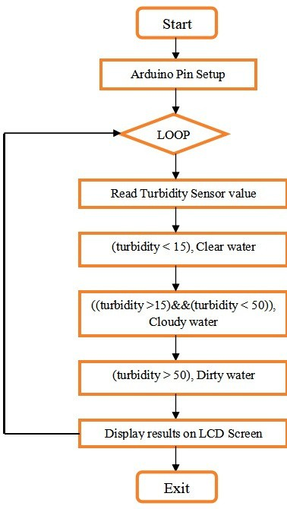
BLOCK DI AGRAM & CONNECTI ON DI AGRAM
3

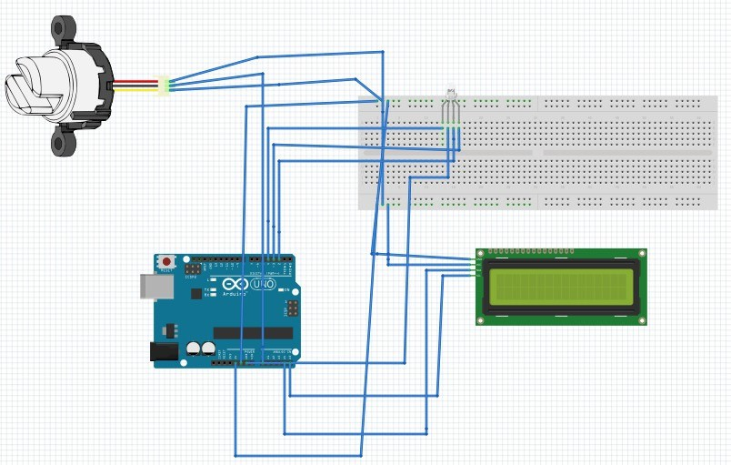
4

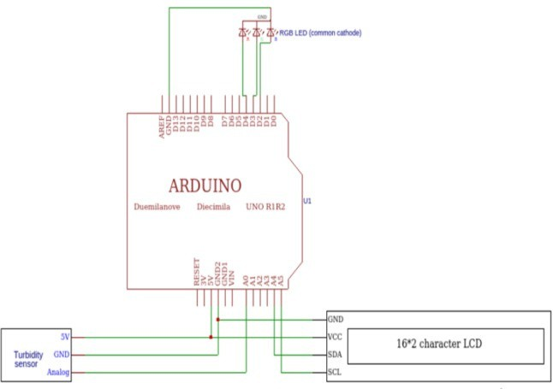

CIRCUIT DIAGRAM
4

5

EQUIPMENT & COMPONENTS
5

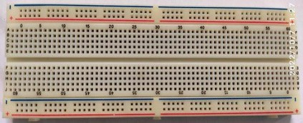
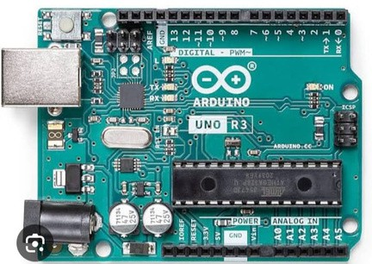
ArduinoUNO

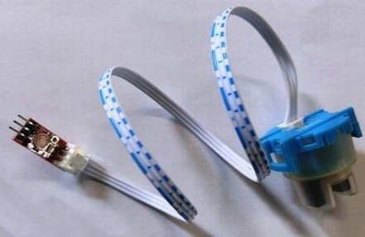
Turbidity Sensor

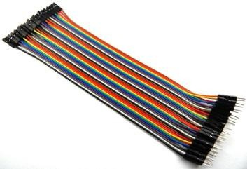
JuJummppeerrwwirreess
i
16*2 I2C LCD

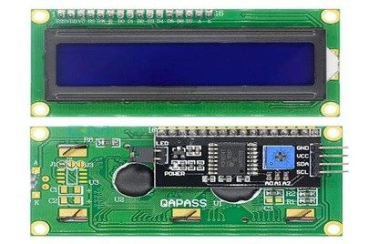
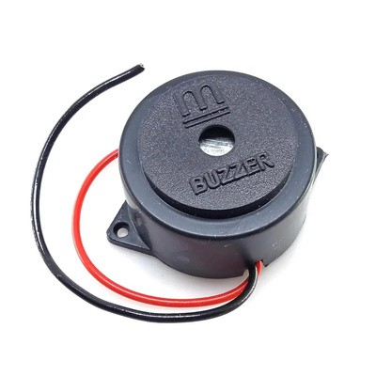
Buzzer

Breadboard

6

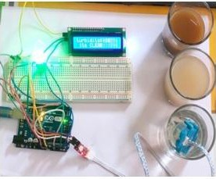
RESULT
6

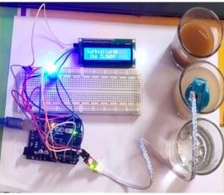
Result of clear water

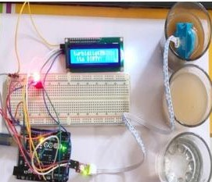
Result of cloudy water

Result of Dirty water

7

8

CONCLUSION
7

The "Measuring Water Quality Using Arduino and Turbidity Sensor" project has been built and tested successfully. System that tracks water quality in real time at the water sources .Researchers can forecast natural processes in the environment, gain knowledge from them, and identify how humans affect an ecosystem by using the Water Quality Monitoring (WQM). In addition to helping with restoration projects, these measurement efforts can guarantee that environmental regulations are being met. The WQM, which makes use of a practical and effective system for tracking drinking water quality.

REFERENCES
8

Irish Franz Almojela, Shyla Mae Gonzales, Karen Gutierrez, Adonis S. Santos, Francis A. Malabanan, Jay Nickson T. Tabing, Christopher B. Escarez, —WatAr: An Arduino-based Drinking Water Quality Monitoring System using Wireless Sensor Network and GSM Module‖ , 2020 IEEE REGION 10 CONFERENCE
(TENCON), no. 6, 16-19 November, Osaka Japan, 2020.

9

Thank you >>>>>

10

